Assignment 2

Due 9/25/15 at 11:59PM

**!!If you have any questions, email me, don’t wait until class to tell me!!**

Recall that in class we went over what classes and methods are. This homework will help you practice creating classes and objects and interacting with them. It will also help you to gain a better understanding of both these topics.

1. Switch into the master branch and go to the Folder named Lessons. In Lesson 1 you will find a PowerPoint named Lesson 1. Go through it.
2. Create a java class in eclipse named Assignment 1 with 3 sub classes.
   1. The first class should be of a house and should contain **5 properties**
      1. The first property must be the cost of the house. The 4 other properties are of your choice.
   2. The second class should be of a car and should contain **4 properties**
      1. The first property should be cost of the car. The 3 other choices are of your choice.
   3. The third class should be of a cellphone and should contain **4 properties**
      1. The first property should be cost of the phone. The other 3 properties are of your choice.

TIP: try to use realistic properties for each of the classes you make and use realistic values for each of the properties of the classes.

1. In your main method, do the following:
   1. Create an object for each of your classes
   2. Assign values for each of your objects’ properties
   3. 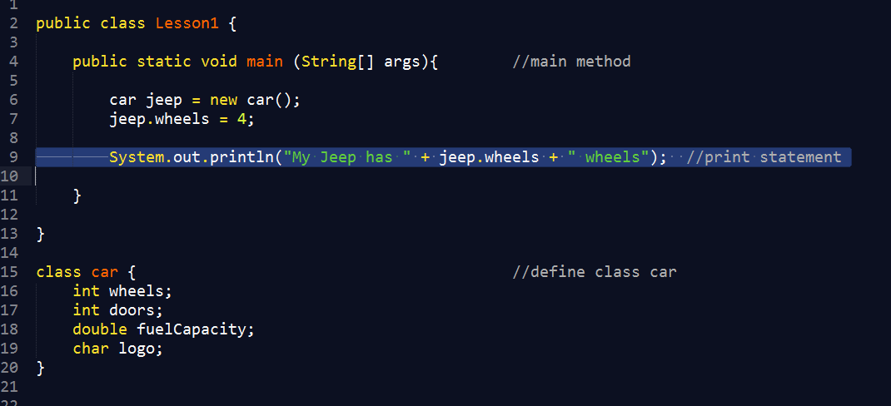Write a print statement for each object stating the property and the value it holds. So for example:
   4. If you need a refresher in java print statements, look at this site: <http://www.cis.upenn.edu/~matuszek/General/JavaSyntax/print-statements.html>
   5. You can also email me/do some googling if you’re having trouble with printing.
2. **CHALLENGE: Create a method which adds up the cost of the house and cost of the car and the cost of the phone. Then if the sum of all those is greater than 250000 print a statement saying “stop spending so much on dunya brother”.**